Start by creating a new variable called “Apple Chance”, as well as an “Apple” item in the database that restores some health upon consumption. Then create a map event over the base (the solid part) of any tree.
Create: Item
- Name: Apple Type: Regular Item
- Consumable: Yes Scope: 1 Ally
- Occasion: Always Effect: Recover 15 HP

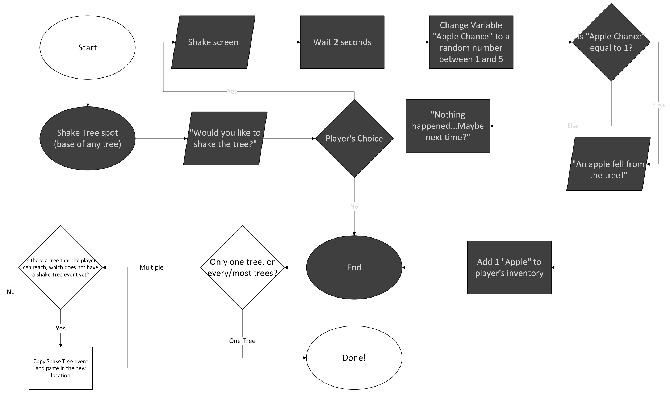
Follow this flow chart to program the game to let the player shake the tree and collect Apples. Note that gray items happen within the event, while white items do not.

